**[SAFE GAURD IOT BASED SMART HELMET]**

**Submitted**

**By**

**(T SYED YOUSUF ALI BU21EECE0100155**

**K STEEV SUSHANTH BU21EECE0100332**

**M PRAVEEN KUMAR BU21EECE0100379)**

**Under the Guidance of (DR. SUBHASHISH TIWARI , PROJECT GUIDE)**

**(Duration: -04/NOV/2024 to 28/MAR/2025)**



**Department of Electrical, Electronics and Communication Engineering [14 Bold]**

**GITAM School of Technology**

**GITAM**

**(DEEMED TO BE UNIVERSITY)**

**(Estd. u/s 3 of the UGC act 1956)**

**NH 207, Nagadenehalli, Doddaballapur taluk, Bengaluru-561203 Karnataka, INDIA.**

**DECLARATION**

**I/We declare that the project work contained in this report is original and it has been done by me under the guidance of my project guide.**

**Name:T Syed Yousuf Ali BU21EECE0100155**

**K Steev Sushanth BU21EECE0100332**

**M Praveen Kumar BU21EECE0100379**

**Date: Signature of the Student**

**Department of Electrical, Electronics and Communication Engineering [14 Bold]**

**GITAM School of Technology, Bengaluru-561203**

**CERTIFICATE**

**This is to certify that (**

**T SYED YOUSUF ALI**

**K STEEV SUSHANTH**

**M PRAVEEN KUMAR) bearing (Regd. No.:BU21EECE0100155, BU21EECE0100322, BU21EECE0100379) has satisfactorily completed Mini Project Entitled in partial fulfillment of the requirements as prescribed by University for VIIIth semester, Bachelor of Technology in “Electrical, Electronics and Communication Engineering” and submitted this report during the academic year 2024-2025.**

**[Signature of the Guide] [Signature of HOD]**

**Table of contents**

**Chapter 1: Introduction 1**

1.1 Overview of the problem statement 1

1.2 Objectives and goals 1

**Chapter 2 : Literature Review 2**

**Chapter 3 : Strategic Analysis and Problem Definition 3**

3.1 SWOT Analysis 3

3.2 Project Plan - GANTT Chart 3

3.3 Refinement of problem statement 3

**Chapter 4 : Methodology 4**

4.1 Description of the approach 4

4.2 Tools and techniques utilized 4

4.3 Design considerations 4

**Chapter 5 : Implementation 5**

5.1 Description of how the project was executed 5

5.2 Challenges faced and solutions implemented 5

**Chapter 6:Results 6**

6.1 outcomes 6

6.2 Interpretation of results 6

6.3 Comparison with existing literature or technologies 6

**Chapter 7: Conclusion 7**

**Chapter 8 : Future Work 8**

Here write Suggestions for further research or development Potential improvements or extensions 8

**References 9**

# Chapter 1**: Introduction**

## 1.1 **Overview of the problem statement**

Motorcycle accidents contribute significantly to road fatalities, often caused by helmet non-compliance, drunk driving, and delayed emergency response. Traditional helmets provide passive protection but lack real-time intelligence to prevent accidents. The Safe Guard IoT-Based Smart Helmet Accessory is designed to enforce helmet usage, detect alcohol consumption, monitor accidents, and provide immediate emergency response, making helmets smarter and more effective in preventing fatalities**.**

The "Safe guard iot based smart helmet accesory" is an innovative safety system designed to prevent accidents and ensure rider safety through real-time monitoring and control. The system integrates an Arduino microcontroller with various sensors, including a IR Sensor to ensure the helmet is worn, an alcohol sensor to detect intoxication, and a MEMS sensor to monitor for accidents. In case of abnormal conditions, such as alcohol detection or an accident, a buzzer sounds an alert, and a relay automatically turns off the vehicle's DC MOTOR. Additionally, GPS and GSM modules provide location tracking and send emergency notifications, while an LCD displays essential information to the rider. This system enhances rider safety by preventing operation under unsafe conditions and providing immediate alerts in case of emergencies.

The " Safe guard iot based smart helmet accesory " is a groundbreaking innovation aimed at enhancing rider safety and reducing road accidents through intelligent monitoring and control mechanisms. By integrating advanced sensors and IoT technologies, the system ensures that critical safety protocols are followed, such as verifying helmet usage, detecting alcohol consumption, and monitoring for potential accidents. Leveraging an Arduino microcontroller, the helmet actively prevents unsafe vehicle operation while providing real-time alerts and location tracking in emergencies, making it a comprehensive solution for rider safety.

An embedded system is one kind of a computer system mainly designed to perform several tasks like to access, process, and store and also control the data in various electronics-based systems. Embedded systems are a combination of hardware and software where software is usually known as firmware that is embedded into the hardware. One of its most important characteristics of these systems is, it gives the o/p within the time limits. Embedded systems support to make the work more perfect and convenient. So, we frequently use embedded systems in simple and complex devices too. The applications of embedded systems mainly involve in our real life for several devices like microwave, calculators, TV remote control, home security and neighborhood traffic control systems, etc.

To make software to work with embedded systems we need to bring software and hardware together .for this purpose we need to burn our source code into microprocessor or microcontroller which is a hardware component and which takes care of all operations to be done by embedded system according to our code.

Generally we write source codes for embedded systems in assembly language, but the processors run only executable files. The process of converting the source code representation of your embedded software into an executable binary image involves three distinct steps:

1. Each of the source files must be compiled or assembled into an object file.
2. All of the object files that result from the first step must be linked together to produce a single object file, called the re-locatable program.
3. Physical memory addresses must be assigned to the relative offsets within the re-locatable program in a process called relocation.

The result of the final step is a file containing an executable binary image that is ready to run on the embedded system.

## 1.2 **Objectives and goals**

**Brief Description**

**- To ensure rider safety by using IoT-based monitoring and control mechanisms.  
- To prevent accidents by verifying helmet usage and detecting alcohol consumption.  
- To enable real-time emergency response through accident detection and GPS-based location tracking.**

Ensure helmet compliance by integrating an IR sensor.

- Prevent drunk driving using an MQ-2 alcohol sensor.

- Detect accidents in real-time with a MEMS sensor.

- Trigger emergency alerts via GPS and GSM modules.

- Introduce a controlled ignition delay mechanism for safer vehicle shutdown.

- Develop an easily attachable accessory for existing helmets**.**

**Main Goals**

* Enhance Rider Safety: Ensure helmet compliance, detect alcohol consumption, and monitor accidents using integrated sensors (IR, alcohol, MEMS) to prevent unsafe vehicle operation.
* Enable Real-Time Alerts: Use GPS and GSM modules for location tracking and emergency notifications during accidents or unsafe conditions

**Additional** **Goals**

* Promote Cost-Effective Solutions: Design the system to be affordable and accessible for widespread adoption.
* Encourage Safer Riding Practices: Address common causes of accidents, such as not wearing helmets and drunk driving, to minimize road fatalities.

# Chapter 2 : Literature Review

Several studies highlight the importance of IoT in road safety. Key references include:

1. IoT-Based Smart Helmet for Accident Detection – Falguni Thakkar et al.

Abstract: Accidents, particularly involving two-wheelers, continue to rise despite government regulations and safety measures. Wearing helmets significantly reduces the risk of injuries, but compliance remains a challenge. The smart helmet system leverages IoT technology to enhance rider safety through accident prevention, detection, and emergency response. Featuring components like Arduino UNO, IR sensors, GSM, and GPS modules, the system ensures the bike engine starts only when the helmet is worn, detects falls, and provides location tracking and alerts for quick medical response. Additionally, ultrasonic sensors offer voice alerts for nearby vehicles, making it a comprehensive safety solution for riders.

1. Design of Smart Helmet for Accident Avoidance – A. Ajithkumar et al.

Abstract:The proposed Helmet Wearing System aims to enhance rider safety by ensuring helmet compliance using Artificial Intelligence. With over 200 million two-wheeler commuters in India, many accidents result from not wearing helmets, drink-and-drive scenarios, and overspeeding. This smart helmet system addresses these issues by mandating helmet use, testing breath for alcohol, monitoring speed, and providing real-time accident detection. In case of an accident, it notifies emergency contacts with location details, ensuring timely medical attention and promoting safer roads.

1. Smart Helmet-Based Accident Detection and Notification System – Dr. M. Kiran Kumar et al.

Abstract: It’s common knowledge that modern youth gravitate toward two wheeled transportation. Drinking and driving and excessive speeding are also widespread problems today. Road accidents are responsible for the deaths of thousands of individuals every year. The primary cause of this is the tardiness of emergency aid that should have been given to the victims. Using the Internet of Things, smart helmets will be able to identify accidents and send alerts to nearby emergency services as well as medical facilities. In this case, an accelerometer module is used to detect accidents by constantly monitoring the deviations from the normal conditions. In the event of a collision, the exact location of the rider can be determined and forwarded to the relevant authorities. The primary function of this system is to transmit accurate information related to the accident in the form of text messages and phone calls to predetermined contacts.

4. Design & Implementation of IoT-Based Smart Helmet for Road Accident Detection – Mohammad Ehsanul Alim et al.

5. IoT-Based Obligatory Usage of Safety Equipment for Alcohol and Accident Detection – Dhruvesh H. Patel et al.

6. Intelligent Motorcycle Monitoring Scheme using IoT with Expert System in Bangladesh – Saima Siddique Tashfia et al.

7. Design and Development of Smart Helmet Using IoT – Sandhya A. Kulkarni et al.

8. IoT-Based Smart Helmet with Motorbike Unit for Enhanced Safety – Pranav Pathak

**REFERENCES**

* **[1] Mohammad Ehsanul Alim, Sarosh Ahmad, Marzieh Naghdi Dorabati, Ihab Hassoun”Design & Implementation of IoT Based Smart Helmet for Road Accident Detection”. ISBN:978-1-7281-8416-6 DOI. 10.1109/IEMCON51383.2020.9284820.**
* **[2] Dhruvesh H. Patel, Parth Sadatiya, Dhruvbhai K. Patel, Prasann Barot “ IoT based Obligatory usage of Safety Equipment for Alcohol and Accident Detection”. ISBN:978-1-7281-0166-8 DOI. 10.1109/ICECA.2019.8822104.**
* **[3] Saima Siddique Tashfia, Rahabul Islam, Sadee Ibn Sultan, Md. Wahidur Rahman, Md. Ahsan Habib, Lubna Yasmin Pinky “ Intelligent Motorcyle Monitoring Scheme using IoT with Expert System in Bangladesh”. DOI. 10.1109/ICCIT51783.2020.9392675.**
* **[4] Sandhya.A.Kulkarni, Sowmya C S, Subhalaskmi P, Tejashwini S A, V R Sanusha, Amitha S and Vandana Jha” Design and Development of Smart Helmet Using IoT” ISBN:978-1-6654-4668-6 DOI. 10.1109/iSSSC50941.2020.9358838.**
* **[5] Pranav Pathak ”IoT based Smart Helmet with Motorbike Unit for Enhanced Safety “ ISBN:978-1-7281-83381. DOI.10.1109/ICACCCN51052.2020.9362986.**

# Chapter 3 : Strategic Analysis and Problem Definition

## 3.1 SWOT Analysis

**Strengths**: Cost-effective, scalable, enhances road safety.

**Weaknesses**: Dependent on external networks (GSM/GPS).

**Opportunities**: Can integrate AI, voice assistants, and health monitoring.

**Threats**: Resistance to adoption due to lack of awareness

### 3.2 Project Plan - GANTT Chart

Introduction 4 NOV - 3 JAN

Consent Form Submission 4 NOV – 10 JAN

Abstract Submission 4 NOV - 10 JAN

Literature survey 4 NOV - 17 JAN

Documentation For review 1 4 NOV - 12 FEB

implementing and testing For review2 4 NOV - 19 FEB

testing and reimplementation for review 3 4 NOV - 10 MAR

##### 3.3 Refinement of problem statement

The accessory aims to prevent accidents before they happen by addressing helmet non-compliance, intoxicated riding, and delayed medical response using IoT technology.

\ Road accidents involving two-wheeler riders are a major safety concern, often resulting in severe injuries or fatalities due to non-compliance with safety measures such as helmet usage and alcohol-free riding. Traditional helmets provide only passive protection and lack advanced features like accident detection, emergency alerts, or vehicle control mechanisms. Additionally, delayed emergency response due to the absence of real-time location tracking further exacerbates the severity of accidents.

To address these challenges, an **IoT-based Smart Helmet Accessory** is proposed, integrating multiple sensors to ensure helmet compliance, detect alcohol consumption, and monitor accidents in real-time. The system leverages **IR sensors**, **alcohol sensors**, and **MEMS-based impact detection** to assess rider conditions, while **GPS and GSM modules** enable instant emergency notifications. By incorporating vehicle control mechanisms that prevent ignition under unsafe conditions, this smart helmet enhances rider safety and enables prompt accident response, significantly reducing the risks associated with two-wheeler travel.

# Chapter 4 : Methodology

## 4.1 Description of the approach

A modular IoT-based accessory with sensors, GSM/GPS modules, and a relay-based ignition control mechanism.

**Project Approach:**

1. **Problem Identification** – Addressing limitations in traditional helmets, such as lack of real-time monitoring, accident detection, and emergency alerts.
2. **Hardware Selection** – Choosing components like Arduino, sensors, and communication modules to implement safety features.
3. **Software Development** – Writing embedded code to process sensor data, control the vehicle, and trigger alerts when necessary.
4. **Integration & Testing** – Combining hardware and software, testing for accurate accident detection, alcohol sensing, and location tracking.
5. **Implementation & Optimization** – Ensuring reliable functionality and improving response times in real-world scenarios.

This approach makes the smart helmet a **proactive safety device**, reducing accident risks by enforcing helmet use, preventing drunk driving, and ensuring timely emergency responses

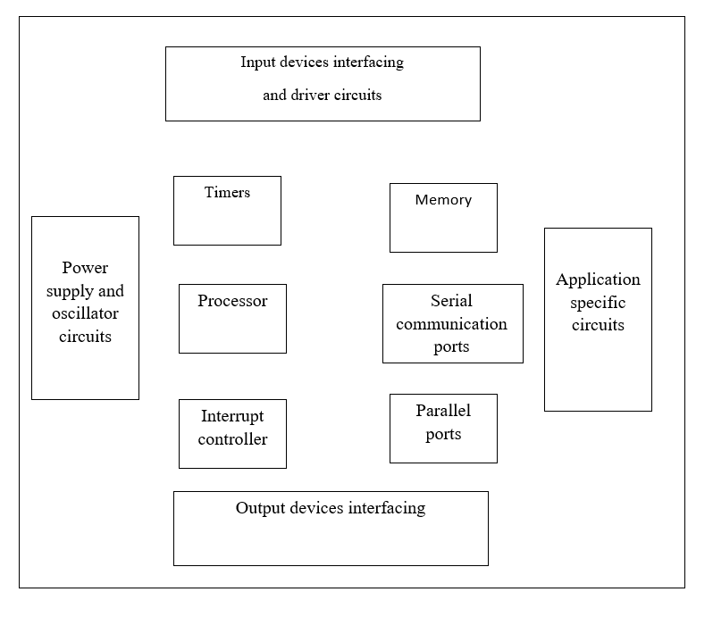

### 4.2 Tools and techniques utilized

- Hardware: Arduino Uno, MQ-2 Alcohol Sensor, IR Sensor, MEMS Sensor, GSM/GPS Modules, Buzzer, LCD Display, Relay, DC MOTOR.

- Software: Arduino IDE, Embedded C, IoT Cloud Platforms.

#### 4.3 Design considerations

- Compatibility with different helmet models.

- Low power consumption.

- Seamless integration with existing motorcycle systems.

As with any electronic system, an embedded system requires a hardware platform on which it performs the operation. Embedded system hardware is built with a microprocessor or microcontroller. The embedded system hardware has elements like input output (I/O) interfaces, user interface, memory and the display. Usually, an embedded system consists of:

* Power Supply
* Processor
* Memory
* Timers
* Serial communication ports
* Output/Output circuits
* System application specific circuits

Embedded systems use different processors for its desired operation. Some of the processors used are

1. Microprocessor

2. Microcontroller

3. Digital signal processor

**Microprocessor vs. Microcontroller**

**Microprocessor**

* **CPU** on a chip.
* We can attach required amount of ROM, RAM and I/O ports.
* Expensive due to external peripherals.
* Large in size
* general-purpose

**Microcontroller**

* **Computer** on a chip
* fixed amount of on-chip ROM, RAM, I/O ports
* Low cost.
* Compact in size.
* Specific –purpose

**Implementation**

Embedded systems have different applications. A few select [applications of embedded systems](https://www.elprocus.com/embedded-systems-real-time-applications/) are smart cards, telecommunications, satellites, missiles, digital consumer electronics, computer networking, etc.

[Embedded Systems in Automobiles](http://www.edgefx.in/importance-of-embedded-systems-in-automobiles-with-applications/)

* Motor Control System
* Engine or Body Safety
* [Robotics](http://www.edgefx.in/top-list-robotics-projects-for-engineering-beginners/) in Assembly Line
* Mobile and E-Com Access

Embedded systems in Telecommunications

* Mobile computing
* Networking
* [Wireless Communications](http://www.edgefx.in/multiple-input-and-multiple-output-mimo-wireless-communications/)

Embedded Systems in Smart Cards

* Banking
* Telephone
* [Security Systems](http://www.edgefx.in/microcontroller-based-projects-on-car-security-systems-using-gsm/)

**IMPLEMENTATION FLOW**

**Stage 1:**

Considering the problems of existing methods and giving solution to that problem by considering the basic requirements for our proposed system

**Stage 2:**

Considering the hardware requirement for the proposed system

For this we need to select the below components:

1. Microcontroller

2. Inputs for the proposed system (ex: sensors, drivers etc..,)

3. Outputs (ex: relays, loads)

**Stage 3:**

After considering hardware requirements, now we need to check out the software requirements. Based on the microcontroller we select there exists different software for coding, compiling, debugging. we need to write source code for that proposed system based on our requirements and compile, debug the code in that software .

After completing all the requirements of software and hardware we need to bring both together to work our system. For this we need to burn our source code into microcontroller, after burning our source code to microcontroller then connect all input and output modules as per our requirement.

# Chapter 5 : Implementation

## 5.1 Description of how the project was executed

The system was developed and tested using real-world scenarios, including helmet-worn detection, alcohol sensing, accident simulations, and emergency alerts.

**Bringing software and hardware together for embedded system:**

To make software to work with embedded systems we need to bring software and hardware together . for this purpose we need to burn our source code into microprocessor or microcontroller which is a hardware component and which takes care of all operations to be done by embedded system according to our code.

Generally we write source codes for embedded systems in assembly language, but the processors run only executable files. The process of converting the source code representation of your embedded software into an executable binary image involves three distinct steps:

1. Each of the source files must be compiled or assembled into an object file.
2. All of the object files that result from the first step must be linked together to produce a single object file, called the re-locatable program.
3. Physical memory addresses must be assigned to the relative offsets within the re-locatable program in a process called relocation.

The result of the final step is a file containing an executable binary image that is ready to run on the embedded system.

**HARDWARE REQUIREMENTS**

**Arduino:**

Arduino Uno is a very valuable addition in the electronics that consists of USB interface, 14 digital I/O pins, 6 analog pins, and Atmega328 microcontroller. It also supports serial communication using Tx and Rx pins.

There are many versions of Arduino boards introduced in the market like Arduino Uno, Arduino Due, Arduino Leonardo, Arduino Mega, however, most common versions are Arduino Uno and Arduino Mega. If you are planning to create a project relating to digital electronics, embedded system, robotics, or IoT, then using Arduino Uno would be the best, easy and most economical option

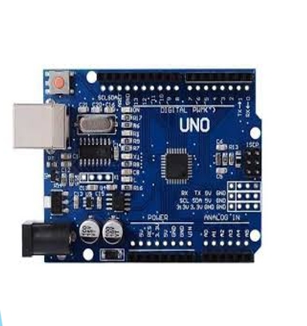

* This board comes with all the features required to run the controller and can be directly connected to the computer through USB cable that is used to transfer the code to the controller using IDE (Integrated Development Environment) software, mainly developed to program Arduino. IDE is equally compatible with Windows, MAC or Linux Systems, however, Windows is preferable to use. Programming languages like C and C++ are used in IDE.
* Apart from USB, battery or AC to DC adopter can also be used to power the board.
* Arduino Uno boards are quite similar to other boards in Arduino family in terms of use and functionality, however, Uno boards don’t come with FTDI USB to Serial driver chip.
* There are many versions of Uno boards available, however, Arduino Nano V3 and Arduino Uno are the most official versions that come with Atmega328 8-bit AVR Atmel microcontroller where RAM memory is 32KB.
* When nature and functionality of the task go complex, Mirco SD card can be added in the boards to make them store more information.

**Features of Arduino**

* Arduino Uno comes with USB interface i.e. USB port is added on the board to develop serial communication with the computer.
* [Atmega328](https://www.theengineeringprojects.com/2017/08/introduction-to-atmega328.html) microcontroller is placed on the board that comes with a number of features like timers, counters, interrupts, PWM, CPU, I/O pins and based on a 16MHz clock that helps in producing more frequency and number of instructions per cycle.

The software used for Arduino devices is called IDE (Integrated Development Environment) which is free to use and required some basic skills to learn it. It can be programmed using C and C++ language.

Some people get confused between **Microcontroller and Arduino**. While former is just an on system 40 pin chip that comes with a built-in microprocessor and later is a board that comes with the microcontroller in the base of the board, bootloader and allows easy access to input-output pins and makes uploading or burning of the program very easy.

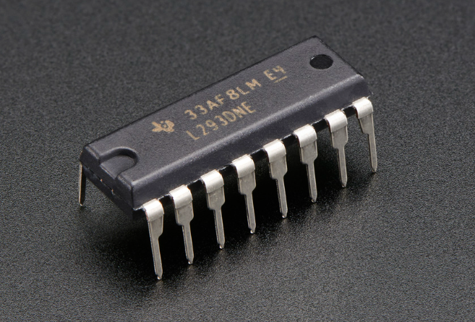

**Pin Description:**

There are several I/O digital and analog pins placed on the board which operates at 5V. These pins come with standard operating ratings ranging between 20mA to 40mA. Internal pull-up resistors are used in the board that limits the current exceeding from the given operating conditions. However, too much increase in current makes these resisters useless and damages the device.

**LED.** Arduino Uno comes with built-in LED which is connected through pin 13. Providing HIGH value to the pin will turn it ON and LOW will turn it OFF.

**Vin.** It is the input voltage provided to the Arduino Board. It is different than 5 V supplied through a USB port. This pin is used to supply voltage. If a voltage is provided through power jack, it can be accessed through this pin.

**5V.** This board comes with the ability to provide voltage regulation. 5V pin is used to provide output regulated voltage. The board is powered up using three ways i.e. USB, Vin pin of the board or DC power jack.

USB supports voltage around 5V while Vin and Power Jack support a voltage ranges between 7V to 20V. It is recommended to operate the board on 5V. It is important to note that, if a voltage is supplied through 5V or 3.3V pins, they result in bypassing the voltage regulation that can damage the board if voltage surpasses from its limit.

**GND.** These are ground pins. More than one ground pins are provided on the board which can be used as per requirement.

**Reset.** This pin is incorporated on the board which resets the program running on the board. Instead of physical reset on the board, IDE comes with a feature of resetting the board through programming.

**IOREF.** This pin is very useful for providing voltage reference to the board. A shield is used to read the voltage across this pin which then select the proper power source.

**PWM.** PWM is provided by 3, 5, 6,9,10, 11pins. These pins are configured to provide 8-bit output PWM.

**SPI.** It is known as Serial Peripheral Interface. Four pins 10(SS), 11(MOSI), 12(MISO), 13(SCK) provide SPI communication with the help of SPI library.

**AREF.** It is called Analog Reference. This pin is used for providing a reference voltage to the analog inputs.

**TWI.** It is called Two-wire Interface. TWI communication is accessed through Wire Library. A4 and A5 pins are used for this purpose.

**Serial Communication.** Serial communication is carried out through two pins called Pin 0 (Rx) and Pin 1 (Tx).

Rx pin is used to receive data while Tx pin is used to transmit data.

**External Interrupts.** Pin 2 and 3 are used for providing external interrupts. An interrupt is called by providing LOW or changing value.

TECHNICAL SPECIFICATIONS

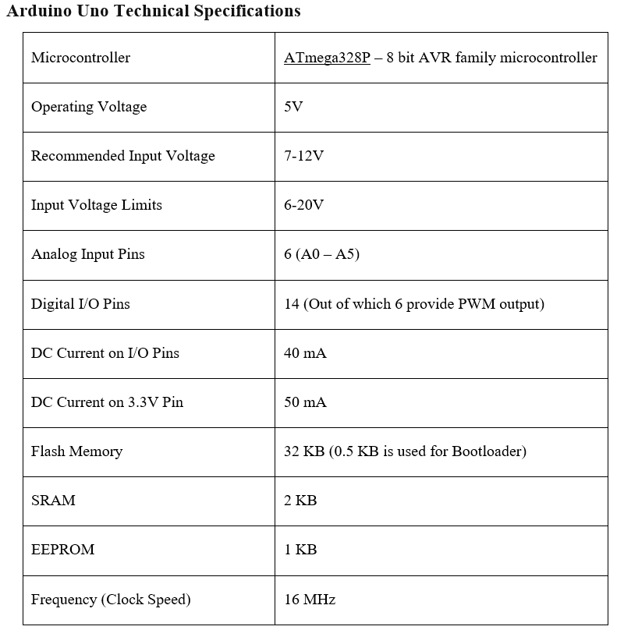

**Communication and Programming:**

Arduino Uno comes with an ability of interfacing with other other Arduino boards, microcontrollers and computer. The Atmega328 placed on the board provides serial communication using pins like Rx and Tx.

The Atmega16U2 incorporated on the board provides a pathway for serial communication using USB com drivers. Serial monitor is provided on the IDE software which is used to send or receive text data from the board. If LEDs placed on the Rx and Tx pins will flash, they indicate the transmission of data.

Arduino Uno is programmed using Arduino Software which a cross-platform application called IDE is written in Java. The AVR microcontroller Atmega328 laid out on the base comes with built-in boot loader that sets you free from using a separate burner to upload the program on the board.

**Applications:**

Arduino Uno comes with a wide range of applications. A larger number of people are using Arduino boards for developing sensors and instruments that are used in scientific research. Following are some main applications of the board.

* [Embedded System](https://www.theengineeringprojects.com/2016/10/what-is-embedded-systems.html)
* Security and Defense System
* Digital Electronics and Robotics
* Parking Lot Counter
* Weighing Machines
* Traffic Light Count Down Timer
* Medical Instrument
* Emergency Light for Railways
* Home Automation
* Industrial Automation

There are a lot of other microcontrollers available in the market that are more powerful and cheap as compared to Arduino board. So, why you prefer Arduino Uno?

Actually, Arduino comes with a big community that is developing and sharing the knowledge with a wide range of audience. Quick support is available pertaining to technical aspects of any electronic project. When you decide Arduino board over other controllers, you don’t need to arrange extra peripherals and devices as most of the functions are readily available on the board that makes your project economical in nature and free from a lot of technical expertise.

**LCD:**

LCD (Liquid Crystal Display) is the innovation utilized in scratch pad shows and other littler PCs. Like innovation for light-producing diode (LED) and gas-plasma, LCDs permit presentations to be a lot more slender than innovation for cathode beam tube (CRT). LCDs expend considerably less power than LED shows and gas shows since they work as opposed to emanating it on the guideline of blocking light.

A LCD is either made with a uninvolved lattice or a showcase network for dynamic framework show. Likewise alluded to as a meager film transistor (TFT) show is the dynamic framework LCD. The uninvolved LCD lattice has a matrix of conductors at every crossing point of the network with pixels. Two conductors on the lattice send a current to control the light for any pixel. A functioning framework has a transistor situated at every pixel crossing point, requiring less current to control the luminance of a pixel.

Some aloof network LCD's have double filtering, which implies they examine the matrix twice with current in the meantime as the first innovation took one sweep. Dynamic lattice, be that as it may, is as yet a higher innovation.

A 16x2 LCD show is an essential module that is generally utilized in various gadgets and circuits. These modules more than seven sections and other multi fragment LEDs are liked. The reasons being: LCDs are affordable; effectively programmable; have no restriction of showing exceptional and even custom characters (not at all like in seven fragments), movements, etc.

A 16x2 LCD implies 16 characters can be shown per line and 2 such lines exist. Each character is shown in a lattice of 5x7 pixels in this LCD. There are two registers in this LCD, in particular Command and Data.

The directions given to the LCD are put away by the order register. An order is a direction given to LCD to play out a predefined assignment, for example, introducing it, clearing its screen, setting the situation of the cursor, controlling presentation, and so forth. The information register will store the information that will be shown on the LCD. The information is the character's ASCII incentive to show on the LCD.

**SENSORS USED**

**ALCOHOL SENSOR(MQ2), IR SENSOR.**

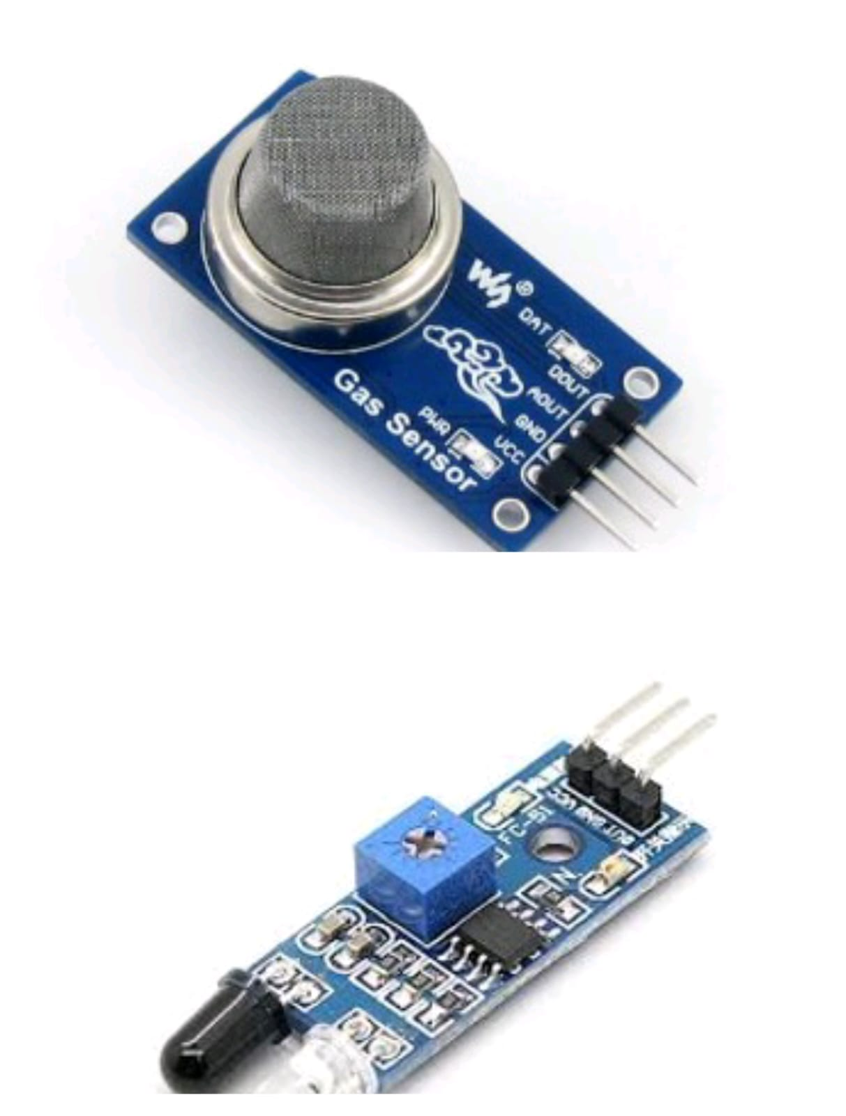

**MQ2 SENSOR:**

The MQ2 sensor is one of the most widely used in the MQ sensor series. It is a MOS (Metal Oxide Semiconductor) sensor. Metal oxide sensors are also known as Chemiresistors because sensing is based on the change in resistance of the sensing material when exposed to alcohol.

The MQ3 is a heater-driven sensor. It is therefore covered with two layers of fine stainless steel mesh known as an “anti-explosion network”. It ensures that the heater element inside the sensor does not cause an explosion because we are sensing flammable gas (alcohol**).**

**IR sensor:**

An [infrared sensor](https://www.elprocus.com/ir-remote-control-basics-operation-application/) is an electronic device, which emits in order to sense some aspects of the surroundings. An IR sensor can measure the heat of an object as well as detects the motion. These types of sensors measures only infrared radiation, rather than emitting it that is called as a [passive IR sensor](https://www.elprocus.com/passive-infrared-pir-sensor-with-applications/). Usually in the infrared spectrum, all the objects radiate some form of thermal radiations. These types of radiations are invisible to our eyes, which can be detected by an infrared sensor. The emitter is simply an IR LED ([Light Emitting Diode](https://www.elprocus.com/explain-different-types-leds-working-applications-engineering-students/)) and the detector is simply an IR photodiode which is sensitive to IR light of the same wavelength as that emitted by the IR LED. When IR light falls on the photodiode, the resistances and these output voltages, change in proportion to the magnitude of the IR light received**.**

**LCD DISPLAY, GPS MODULE, BUZZER, ARDUINO UNO**

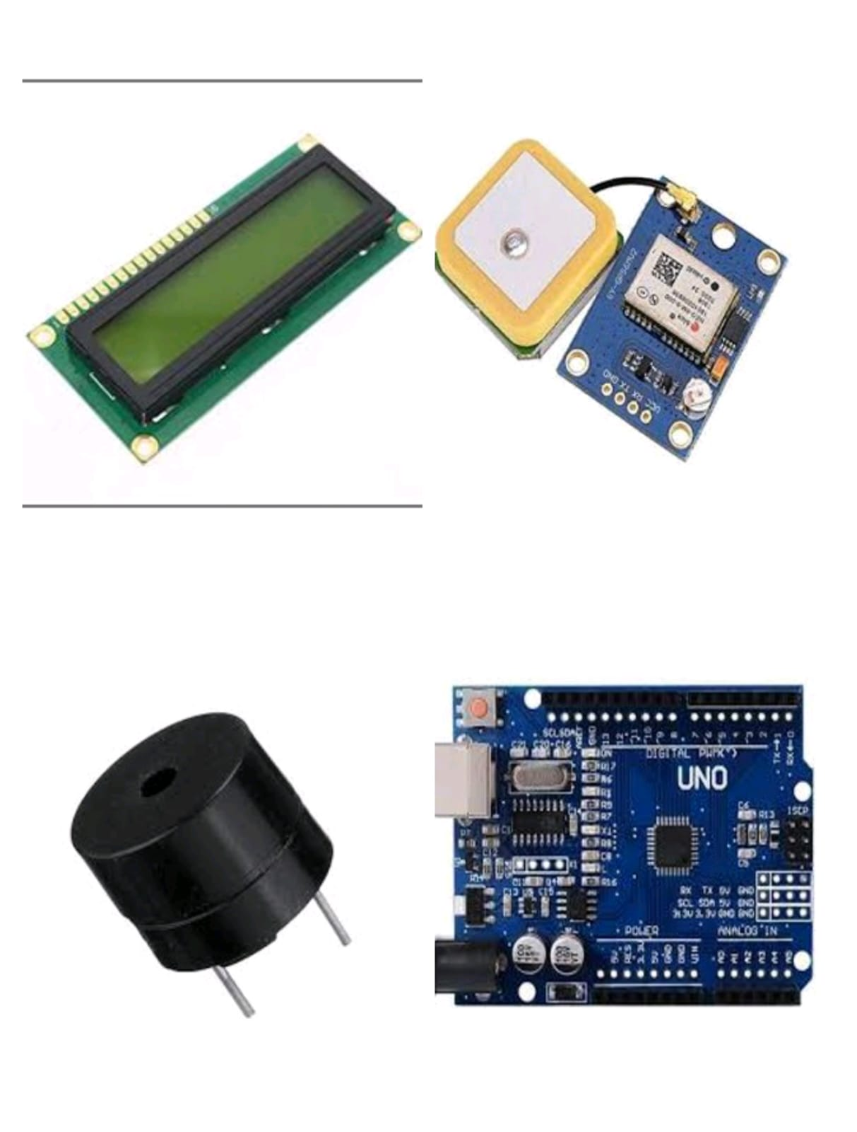 LCD (Liquid Crystal Display) is the innovation utilized in scratch pad shows and other littler PCs. Like innovation for light-producing diode (LED) and gas-plasma, LCDs permit presentations to be a lot more slender than innovation for cathode beam tube (CRT). LCDs expend considerably less power than LED shows and gas shows since they work as opposed to emanating it on the guideline of blocking light.

A LCD is either made with a uninvolved lattice or a showcase network for dynamic framework show. Likewise alluded to as a meager film transistor (TFT) show is the dynamic framework LCD. The uninvolved LCD lattice has a matrix of conductors at every crossing point of the network with pixels. Two conductors on the lattice send a current to control the light for any pixel. A functioning framework has a transistor situated at every pixel crossing point, requiring less current to control the luminance of a pixel.

Some aloof network LCD's have double filtering, which implies they examine the matrix twice with current in the meantime as the first innovation took one sweep. Dynamic lattice, be that as it may, is as yet a higher innovation.

A 16x2 LCD show is an essential module that is generally utilized in various gadgets and circuits. These modules more than seven sections and other multi fragment LEDs are liked. The reasons being: LCDs are affordable; effectively programmable; have no restriction of showing exceptional and even custom characters (not at all like in seven fragments), movements, etc.

A 16x2 LCD implies 16 characters can be shown per line and 2 such lines exist. Each character is shown in a lattice of 5x7 pixels in this LCD. There are two registers in this LCD, in particular Command and Data.

The directions given to the LCD are put away by the order register. An order is a direction given to LCD to play out a predefined assignment, for example, introducing it, clearing its screen, setting the situation of the cursor, controlling presentation, and so forth. The information register will store the information that will be shown on the LCD. The information is the character's ASCII incentive to show on the LCD.

**GPS:**

Global Positioning System (GPS) is a satellite-based system that uses satellites and ground stations to measure and compute its position on Earth.

GPS is also known as Navigation System with Time and Ranging (NAVSTAR) GPS.

GPS receiver needs to receive data from at least 4 satellites for accuracy purpose. GPS receiver does not transmit any information to the satellites.

This GPS receiver is used in many applications like smartphones, Cabs, Fleet management etc.

**How GPS Works**

GPS receiver uses a constellation of satellites and ground stations to calculate accurate location wherever it is located.

These GPS satellites transmit information signal over radio frequency (1.1 to 1.5 GHz) to the receiver. With the help of this received information, a ground station or GPS module can compute its position and time.

**How GPS Receiver Calculates its Position and Time**

GPS receiver receives information signals from GPS satellites and calculates its distance from satellites. This is done by measuring the time required for the signal to travel from satellite to the receiver.

**Buzzer:**

A buzzer or beeper is an audio signaling device, which may be mechanical, electromechanical, or piezoelectric. Typical uses of buzzers and beepers include alarm devices, timers and confirmation of user input such as a mouse click or keystroke. Buzzer is an integrated structure of electronic transducers, DC power supply, widely used in computers, printers, copiers, alarms, electronic toys, automotive electronic equipment, telephones, timers and other electronic products for sound devices. Active buzzer 5V Rated power can be directly connected to a continuous sound, this section dedicated sensor expansion module and the board in combination, can complete a simple circuit design, to "plug and play.

**ARDUINO UNO**

Arduino Uno is a very valuable addition in the electronics that consists of USB interface, 14 digital I/O pins, 6 analog pins, and Atmega328 microcontroller. It also supports serial communication using Tx and Rx pins.

There are many versions of Arduino boards introduced in the market like Arduino Uno, Arduino Due, Arduino Leonardo, Arduino Mega, however, most common versions are Arduino Uno and Arduino Mega. If you are planning to create a project relating to digital electronics, embedded system, robotics, or IoT, then using Arduino Uno would be the best, easy and most economical option.

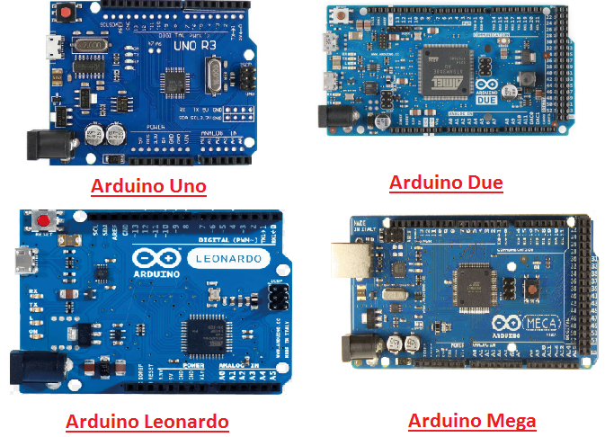

It is an open-source platform, means the boards and software are readily available and anyone can modify and optimize the boards for better functionality.

The software used for Arduino devices is called IDE (Integrated Development Environment) which is free to use and required some basic skills to learn it. It can be programmed using C and C++ language.

Some people get confused between **Microcontroller and Arduino**. While former is just an on system 40 pin chip that comes with a built-in microprocessor and later is a board that comes with the microcontroller in the base of the board, bootloader and allows easy access to input-output pins and makes uploading or burning of the program very easy.

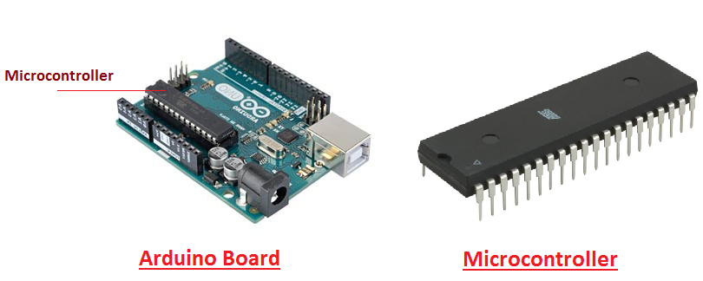

While learning microcontroller requires some expertise and skills.

Nevertheless, we can say every Arduino is basically a [microcontroller](https://www.theengineeringprojects.com/2018/03/introduction-to-microcontrollers.html) but not every microcontroller is an Arduino.

**Introduction to Arduino**

* **Arduino Uno** is a microcontroller board developed by Arduino.cc which is an open-source electronics platform mainly based on AVR microcontroller Atmega328.
* First Arduino project was started in Interaction Design Institute Ivrea in 2003 by David Cuartielles and Massimo Banzi with the intention of providing a cheap and flexible way to students and professional for controlling a number of devices in the real world.
* The current version of Arduino Uno comes with USB interface, 6 analog input pins, 14 I/O digital ports that are used to connect with external electronic circuits. Out of 14 I/O ports, 6 pins can be used for PWM output.
* It allows the designers to control and sense the external electronic devices in the real world

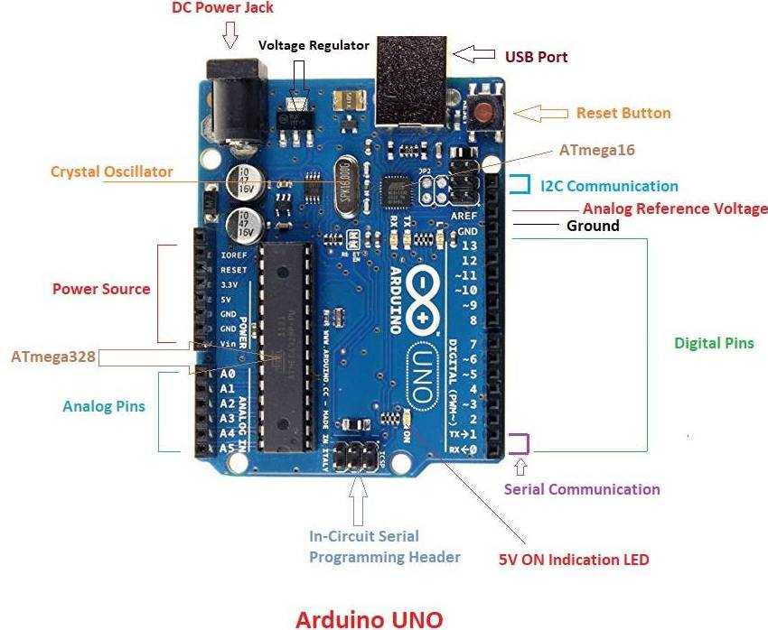

* This board comes with all the features required to run the controller and can be directly connected to the computer through USB cable that is used to transfer the code to the controller using IDE (Integrated Development Environment) software, mainly developed to program Arduino. IDE is equally compatible with Windows, MAC or Linux Systems, however, Windows is preferable to use. Programming languages like C and C++ are used in IDE.
* Apart from USB, battery or AC to DC adopter can also be used to power the board.
* Arduino Uno boards are quite similar to other boards in Arduino family in terms of use and functionality, however, Uno boards don’t come with FTDI USB to Serial driver chip.
* There are many versions of Uno boards available, however, Arduino Nano V3 and Arduino Uno are the most official versions that come with Atmega328 8-bit AVR Atmel microcontroller where RAM memory is 32KB.
* When nature and functionality of the task go complex, Mirco SD card can be added in the boards to make them store more information.

**Features of Arduino**

* Arduino Uno comes with USB interface i.e. USB port is added on the board to develop serial communication with the computer.
* [Atmega328](https://www.theengineeringprojects.com/2017/08/introduction-to-atmega328.html) microcontroller is placed on the board that comes with a number of features like timers, counters, interrupts, PWM, CPU, I/O pins and based on a 16MHz clock that helps in producing more frequency and number of instructions per cycle.

**DC MOTOR, GSM MODULE, MOTOR DRIVE, ACCELEROMETER(MEMS SENSOR).**

**DC MOT**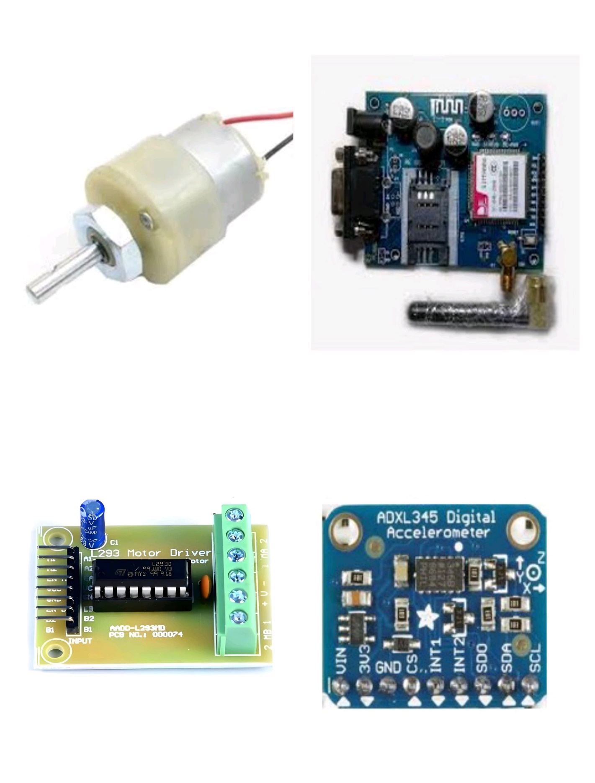

**DC MOTOR**

A direct current (DC) motor is a type of electric machine that converts electrical energy into mechanical energy. DC MOTORs take electrical power through direct current, and convert this energy into mechanical rotation.

DC MOTORs use magnetic fields that occur from the electrical currents generated, which powers the movement of a rotor fixed within the output shaft. The output torque and speed depends upon both the electrical input and the design of the motor.

How DC MOTORs work

The term ‘DC MOTOR’ is used to refer to any rotary electrical machine that converts direct current electrical energy into mechanical energy. DC MOTORs can vary in size and power from small motors in toys and appliances to large mechanisms that power vehicles, pull elevators and hoists, and drive steel rolling mills.

But how do DC MOTORs work?

DC MOTORs include two key components: a stator and an armature. The stator is the stationary part of a motor, while the armature rotates. In a DC MOTOR, the stator provides a rotating magnetic field that drives the armature to rotate.

A simple DC MOTOR uses a stationary set of magnets in the stator, and a coil of wire with a current running through it to generate an electromagnetic field aligned with the centre of the coil. One or more windings of insulated wire are wrapped around the core of the motor to concentrate the magnetic field.

The windings of insulated wire are connected to a commutator (a rotary electrical switch), that applies an electrical current to the windings. The commutator allows each armature coil to be energised in turn, creating a steady rotating force (known as torque).

When the coils are turned on and off in sequence, a rotating magnetic field is created that interacts with the differing fields of the stationary magnets in the stator to create torque, which causes it to rotate. These key operating principles of DC MOTORs allow them to convert the electrical energy from direct current into mechanical energy through the rotating movement, which can then be used for the propulsion of objects.

Who invented the DC MOTOR?

This amazing piece of electrical equipment has revolutionised our lives in many ways, but who invented the DC MOTOR? As with all major innovations, there are many people who had a role to play through the development of similar mechanisms.

In the US, Thomas Davenport is widely celebrated as the inventor of the first electric motor, and undoubtedly he was the first to patent a useable electric motor in 1837. Davenport, however, was not the first person to build an electric motor, with various inventors in Europe having already developed more powerful versions by the time Davenport filed his patent.

In 1834, Moritz Jacobi had presented a motor that was three times as powerful as the one Davenport would later patent, while Sibrandus Stratingh and Christopher Becker were the first to demonstrate a practical application for an electric motor, by running a small model car in 1835**.**

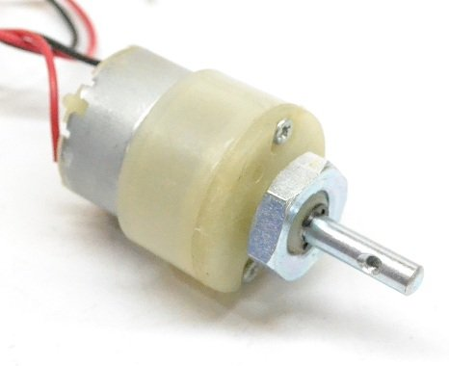

**MEMS Sensor:**

The term MEMS stands for micro-electro-mechanical systems. These are a set of devices, and the characterization of these devices can be done by their tiny size & the designing mode. The designing of these sensors can be done with the 1- 100-micrometer [components](https://www.elprocus.com/basic-components-used-electronics-electrical/). These devices can differ from small structures to very difficult electromechanical systems with numerous moving elements beneath the control of incorporated micro-electronics. Usually, these sensors include mechanical micro-actuators, micro-structures, micro-electronics, and micro-sensors in one package. This article discusses what is a MEMS sensor, working principle, advantages and it’s applications

**GSM**

GSM is a mobile communication modem; it is stands for global system for mobile communication (GSM). The idea of GSM was developed at Bell Laboratories in 1970.  It is widely used mobile communication system in the world. GSM is an open and digital cellular technology used for transmitting mobile voice and data services operates at the 850MHz, 900MHz, 1800MHz and 1900MHz frequency bands.

GSM system was developed as a digital system using time division multiple access (TDMA) technique for communication purpose. A GSM digitizes and reduces the data, then sends it down through a channel with two different streams of client data, each in its own particular time slot. The digital system has an ability to carry 64 kbps to 120 Mbps of data rates.

There are various cell sizes in a GSM system such as macro, micro, pico and umbrella cells. Each cell varies as per the implementation domain. There are five different cell sizes in a GSM network macro, micro, pico and umbrella cells. The coverage area of each cell varies according to the implementation environment.

Time Division Multiple Access

TDMA technique relies on assigning different time slots to each user on the same frequency. It can easily adapt to data transmission and voice communication and can carry 64kbps to 120Mbps of data rate.

GSM Architecture

A GSM network consists of the following components:

* A Mobile Station:  It is the mobile phone which consists of the transceiver, the display and the processor and is controlled by a SIM card operating over the network.
* Base Station Subsystem: It acts as an interface between the mobile station and the network subsystem. It consists of the Base Transceiver Station which contains the radio transceivers and handles the protocols for communication with mobiles. It also consists of the Base Station Controller which controls the Base Transceiver station and acts as a interface between the mobile station and mobile switching centre.
* Network Subsystem: It provides the basic network connection to the mobile stations. The basic part of the Network Subsystem is the Mobile Service Switching Centre which provides access to different networks like ISDN, PSTN etc. It also consists of the Home Location Register and the Visitor Location Register which provides the call routing and roaming capabilities of GSM. It also contains the Equipment Identity Register which maintains an account of all the mobile equipments wherein each mobile is identified by its own IMEI number. IMEI stands for International Mobile Equipment Identity.

**Power supply:**

A power supply is a component that provides at least one electrical charge with power. It typically converts one type of electrical power to another, but it can also convert a different Energy form in electrical energy, such as solar, mechanical, or chemical.

A power supply provides electrical power to components. Usually the term refers to devices built into the powered component. Computer power supplies, for example, convert AC current to DC current and are generally located along with at least one fan at the back of the computer case.

Most computer power supplies also have an input voltage switch that, depending on the geographic location, can be set to 110v/115v or 220v/240v. Due to the different power voltages supplied by power outlets in different countries, this switch position is crucial.

### 5.2 Challenges faced and solutions implemented

- Interference in Alcohol Sensing: Calibrated MQ-2 sensor for higher accuracy.

- Network Delays in Emergency Alerts: Optimized GSM module settings.

- Helmet Compatibility Issues: Designed adjustable mounting mechanism.

1. **Integration of Sensors**
   * **Challenge**: Ensuring seamless communication between IR, alcohol, and MEMS sensors was difficult due to signal interference and compatibility issues.
   * **Solution**: Implemented error correction algorithms and optimized sensor placement to minimize interference and improve reliability.
2. **Power Management**
   * **Challenge**: Continuous monitoring by multiple sensors led to excessive power consumption, reducing battery life.
   * **Solution**: Introduced power-saving modes and selected energy-efficient components to extend battery life without compromising performance.
3. **Real-Time Communication Delays**
   * **Challenge**: Delays in transmitting GPS and GSM alerts due to network latency affected emergency response time.
   * **Solution**: Optimized data transmission protocols to enhance efficiency and reduce delays in sending alerts.
4. **Accuracy of Alcohol Detection**
   * **Challenge**: Alcohol sensors occasionally provided false readings due to environmental factors such as temperature variations.
   * **Solution**: Calibrated the alcohol sensor to filter out anomalies and improve detection accuracy.
5. **Accident Detection Reliability**
   * **Challenge**: MEMS sensors sometimes misinterpreted normal movements as accidents.
   * **Solution**: Implemented threshold-based impact detection to differentiate between normal riding conditions and actual accidents.
6. **CONNECTION PART**

* It is a most difficult and mot important part in the mechanism.

1. **RELAYS**

* While connections and while coding part it is must we should give the relay for the correct working of the project and give the good results.
* In this also we have faced challenges.

# Chapter 6:Results

## 6.1 outcomes

- Successful enforcement of helmet usage.

- Reliable alcohol detection preventing ignition.

- Accurate accident detection triggering emergency alerts.

- Controlled ignition delay instead of abrupt shutdown.

### 6.2 Interpretation of results

### The accessory effectively enhances rider safety by providing real-time monitoring and intervention mechanisms.

### The system successfully prevented vehicle ignition when the helmet was not worn or if alcohol was detected, ensuring safety compliance.

### The MEMS-based accident detection mechanism accurately identified sudden impacts and triggered emergency alerts.

### Real-time notifications via the GSM module were successfully transmitted, enabling quick response in emergency situations.

### The combination of GPS and GSM modules provided accurate location tracking, ensuring timely assistance to accident victims.

### The integration of an LCD display provided the rider with essential safety information in real time.

### 

#### 6.3 Comparison with existing literature or technologies

Traditional helmets do not incorporate safety features like real-time monitoring or emergency notifications. While some helmets include basic protections, such as providing head coverage and sometimes preventing the ignition of vehicles when not worn, they lack advanced functionalities like accident detection, alcohol detection, or location tracking. These limitations pose significant risks as they do not prevent riders from driving under unsafe conditions or ensure immediate response in case of emergencies, leading to delayed help and increasing the severity of accidents

* **Traditional Helmets**: Offer only passive protection without real-time monitoring or safety automation.
* **Similar IoT-Based Smart Helmets in Literature**:
  + Compared to previous smart helmet models, this system enhances accident detection accuracy by integrating **MEMS sensors** with **real-time GPS/GSM alerts**.
  + Unlike models that require manual alert triggers, this system automates emergency notifications, significantly reducing response time.
  + The alcohol detection mechanism is more refined, with enhanced calibration to minimize false positives.
  + The system includes a **vehicle ignition control mechanism**, preventing riders from operating the bike under unsafe conditions, which is an improvement over many existing designs.

This comprehensive smart helmet system sets itself apart by offering a fully integrated **IoT-based safety solution**, ensuring real-time accident prevention, detection, and response.

Comparing to the helmets existing in the market they are high cost and not getting purchased because of higher costs

By out helmet it is an add on application for the existing helmet it will be considered by the many of the people who are using motor vehicles

Also we can easily fix the application to the vehicle and helmet.

The rider should make sure for buying the helmet and add the accessories for the vehicle.

Unlike traditional helmets, this accessory offers active prevention mechanisms and emergency response features.

**OUR PROPOSED METHOD**

The proposed system, "Safe guard iot based smart helmet accesory" overcomes these limitations by integrating multiple sensors and IoT technologies for enhanced safety. It ensures the rider is wearing a helmet and has not consumed alcohol through a IR Sensor and alcohol sensor, respectively. Additionally, a MEMS sensor detects accidents, while the GPS and GSM modules provide real-time location tracking and send alerts in abnormal situations. The system also includes a buzzer and LCD for immediate alerts and status display, and it shuts off the vehicle's motor via a relay during unsafe conditions, offering a comprehensive solution to rider safety.

# Chapter 7: Conclusion

Here write Suggestions for further research or development and Potential improvements or extensions

- Wireless communication between helmet and bike ignition.

- AI-powered voice assistant for navigation and safety alerts.

- Airbag integration for enhanced crash protection.

- Health monitoring sensors to detect fatigue or medical distress.

- Real-time driving behavior analysis using AI to prevent risky riding patterns.

IoT-Based Smart Helmet Accessory, has been progressing in structured phases, ensuring a systematic approach to implementation and testing.

⿡ **Iteration 1** - Alcohol Detection (Completed) - Successfully integrated and tested the MQ2 alcohol sensor. - Ensured that if alcohol is detected, the buzzer sounds and motor stops. - Data displayed on LCD screen and sent to emergency contacts.

⿢ **Iteration 2** - Helmet Detection (In Progress) - Implemented an IR sensor to verify helmet usage before enabling the motor. - Current focus: Fine-tuning sensor accuracy to prevent false detection.

⿣ **Iteration 3** - Accident Detection & Emergency Alert (Upcoming) - Integration of MEMS accelerometer (ADXL345) for accident detection. - Testing of GPS and GSM modules to send emergency location alerts.

* The **Safe Guard IoT-Based Smart Helmet** Accessory successfully enhances rider safety through the integration of IoT-based real-time monitoring and control mechanisms. By incorporating **alcohol detection**, helmet verification, and accident detection, the system ensures that riders adhere to safety protocols before operating a vehicle. The use of **sensors** and emergency alert mechanisms enables quick detection of unsafe conditions, making it an effective solution for accident prevention and rapid response.
* This smart helmet not only prevents unsafe riding conditions but also minimizes the response time for emergency services, potentially saving lives. The project demonstrates the practical application of embedded systems and IoT in road safety, offering a cost-effective, user-friendly, and scalable solution.

The **"Safe Guard IoT-Based Smart Helmet Accessory"** is a significant advancement in rider safety, integrating **real-time monitoring, accident prevention, and emergency response technologies**. By utilizing an **IR sensor** to ensure helmet compliance, an **alcohol sensor** to prevent drunk driving, and a **MEMS sensor** to detect accidents, the system proactively enhances road safety. The inclusion of **GPS and GSM modules** allows for **real-time location tracking and emergency notifications**, ensuring prompt assistance in case of an accident. Additionally, the **buzzer, relay, and LCD display** contribute to immediate alerts and vehicle control, further preventing unsafe riding conditions.

By combining **IoT technologies, sensors, and automation**, this smart helmet accessory offers a **comprehensive safety solution** for motorcyclists. The system effectively **reduces the risk of accidents, prevents vehicle operation under hazardous conditions, and ensures timely intervention during emergencies**. Thus, this project contributes to **safer roads, improved rider security, and enhanced emergency response mechanisms**, making it a **valuable innovation in the field of intelligent transportation and safety systems**.

# 

# Chapter 8 : Future Work

#### Here write Suggestions for further research or development Potential improvements or extensions

To further improve rider safety and user experience, the system can be enhanced with:

Wireless Communication: Bluetooth/Wi-Fi integration between the helmet accessory and bike ignition for seamless control.

AI-Powered Voice Assistant: Enabling hands-free interaction for navigation, weather updates, and emergency support.

Smart Airbag System: Deploying an airbag in case of a detected accident to reduce impact injuries.

#### 

# References

* [1] Mohammad Ehsanul Alim, Sarosh Ahmad, Marzieh Naghdi Dorabati, Ihab Hassoun”Design & Implementation of IoT Based Smart Helmet for Road Accident Detection”. ISBN:978-1-7281-8416-6 DOI. 10.1109/IEMCON51383.2020.9284820.
* [2] Dhruvesh H. Patel, Parth Sadatiya, Dhruvbhai K. Patel, Prasann Barot “ IoT based Obligatory usage of Safety Equipment for Alcohol and Accident Detection”. ISBN:978-1-7281-0166-8 DOI. 10.1109/ICECA.2019.8822104.
* [3] Saima Siddique Tashfia, Rahabul Islam, Sadee Ibn Sultan, Md. Wahidur Rahman, Md. Ahsan Habib, Lubna Yasmin Pinky “ Intelligent Motorcyle Monitoring Scheme using IoT with Expert System in Bangladesh”. DOI. 10.1109/ICCIT51783.2020.9392675.
* [4] Sandhya.A.Kulkarni, Sowmya C S, Subhalaskmi P, Tejashwini S A, V R Sanusha, Amitha S and Vandana Jha” Design and Development of Smart Helmet Using IoT” ISBN:978-1-6654-4668-6 DOI. 10.1109/iSSSC50941.2020.9358838.
* [5] Pranav Pathak ”IoT based Smart Helmet with Motorbike Unit for Enhanced Safety “ ISBN:978-1-7281-83381. DOI.10.1109/ICACCCN51052.2020.9362986.